Sustaining Biodiversity: The Species Approach

1‐ Biodiversity & Its Protection:

• Biodiversity:
- by definition includes the:

- species diversity variety of different species.
- genetic diversity genetic variability among individuals within each species.
- ecological diversity variety of ecosystems.
- functional diversity variety in the functions needed for the survival of species & biological communities.

- one of the most important forms of natural capital.

- It is important to preserve biodiversity mainly because it has two types of values:

- Intrinsic Value: value of an organism, species, ecosystem, or earth’s biodiversity based on its existence, regardless of whether it has any usefulness to humans.

protecting biodiversity on this basis an ethical decision (species simply has the right
to exist).

- Instrumental Value: value of an organism, species, ecosystem, or earth’s biodiversity based on its usefulness to humans in the form of economic & ecological services.

- Some major ecologic/economic benefits of biodiversity:

- maintains the structure & function of ecosystems.
- controls population of pests & other species.
- provides a variety of options for nature to adapt to environmental changes.
- supplies us & other species with food, medicine, genetic information, jobs (paper industries, food industries…) & recreation / tourism (ecotourism).

n.b: Ecotourism:
- upside effect or advantage bring money to the local economy.
- downside effect or disadvantage disturbs wildlife if not well organized.

2‐ Species Extinction:

- The three levels / types of species extinction are:
- Species’ Local Extinction: no longer found in an area it once inhabited but is still found elsewhere in the world.
- Species’ Ecological Extinction: few members left can no longer play its ecological role.
- Species’ Biological Extinction: not found anywhere anymore & forever.

- Species heading towards biological extinction are classified into 2 categories:
- Endangered Species: so few individual survivors could soon become extinct.
- Threatened Species or Vulnerable Species: still abundant declining in number likely to become endangered in the near future.

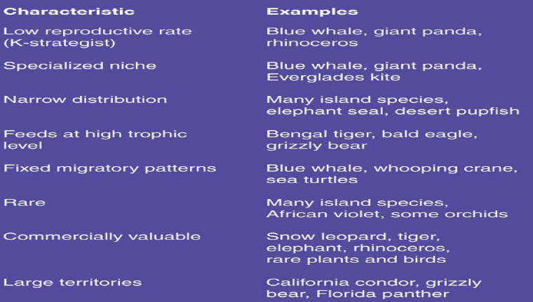
- Some species have some characteristics that make them prone to Ecological & Biological Extinction. These are:

- The number of species we are losing per year depend on:

- Number of species on earth
- Rate of species extinction:

- Extinction Rates estimated by measurements & models not very accurate mainly because it is based on incomplete data.
• Problems with extinction rate estimation:
1‐ species extinction process takes long time not easy to document.
2‐ only 1.4 million species identified up till now.
3‐ little knowledge about most of the identified specie.

- Scientists estimations of annual extinction rate:
- before human’s arrival on earth about 0.0001% per year
- currently 0.01% to 1% per year.

• According to researchers:
At a rate of 1% extinction by 2030, at least 1/5 of the world’s current animal & plant species could be lost.

- The International Union for Conservation of Nature & Natural Resources (IUCN) (2005) Red List for species extinction 16,000 species at risk of extinction.

3‐ Causes of Species Extinction:

- The most important causes for species extinction are represented by the acronym “HIPPO”.

H: Habitat destruction, degradation & fragmentation.
I: Invasive species
P: Population growth
P: Pollution
O: Overharvesting / Overexploitation

• Greatest threat to wild species Habitat Loss (H)

- Habitat destruction, degradation & fragmentation:

- Habitat Loss no more exists
- Habitat Degradation negatively affected
- Habitat Fragmentation:
- Area of habitats divided into smaller, scattered “habitat islands” (due to roads, development, agriculture…).
-Habitat Island: any habitat surrounded by a different one, may be surrounded by mining, industries.

- Habitat Fragmentation Effects:
- blocking of migration routes.
- dividing population of species into smaller & more isolated groups more vulnerable to predators, competition.
- creating barriers 􀃆􀃆limiting species dispersion, getting enough food& finding mates.

- Invasive/Nonnative Species:

• Invasive / Nonnative Species: Migrating, deliberately or intentionally introduced species into an ecosystem.
• Intentional nonnative species introduction: ex: bees & honey in Brazil.
• Accidental nonnative species introduction:
- usually by: shiploads, aircraft loads…
- ex: 1930 extremely aggressive Argentina Fire Aunts arrived to the U.S.A on shiploads of coffee had no predators wiped out 90% of the native aunt population & developed resistance to pesticides…
• Second most important cause of species extinction.

- Nonnative species can have, on native species & the ecosystem:
- positive effects (provide food, medicine…)
- negative effects (wipe out native species…)

• Nonnative species sometimes have no predators, parasites or competitors no population control reduction or wiping out of native species ecological disruption “Biotic Pollution” occurs.

• Biotic Pollution: harmful ecologic & economic effect caused by the presence of invasive/nonnative species

• Once invasive species arrive extremely hard to slow their spread.

• Some measures, at the national level, could be:

- Fund & increase research identify invader characteristics & ecosystems vulnerable to invaders + find & introduce natural predators, parasites & diseases‐causing bacteria & viruses to control invaders.

- Ground surveys & satellite observations detect / monitor species invasions + develop better models for invaders’ spread predictions.

- Inspection of imported goods (by ships, aircrafts…) & travelers goods.

- Identify major harmful invader species & pass international laws banning their transfer.

- Some general characteristics of successful invasive species & ecosystems vulnerable to invading species:

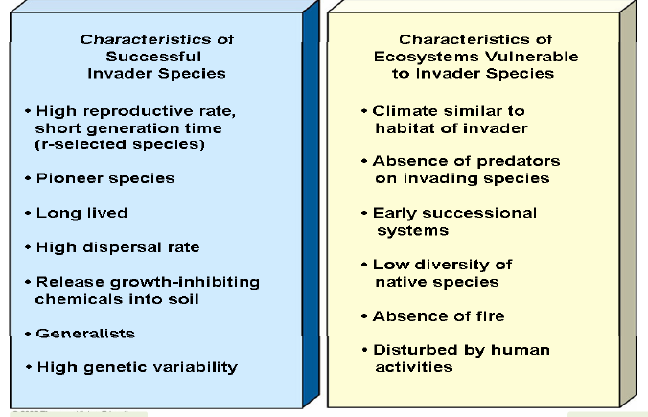

- Population Growth & Pollution (Climate Change):

- Population growth, pollution (climate change) increased species’ extinction.

- Population growth (past & present) excessive & wasteful resources’ consumption extinction of some species increased human ecological footprints.

- Pollution: ex: unintended effects of pesticides threaten some species with extinction.

- Climate Change in the past, most climate changes took place over a long period of time species had enough time to adapt(no more the case nowadays).

- Overexploitation/Overharvesting:

• Overexploitation of species by humans takes four very common forms. These are:
1‐ Illegal killing or sale of wild species:
- species killed sold alive or as valuable parts extinction threat.
2‐ Killing species we don’t like:
- some species bother humans or cause economic loss killed extinction threat.
3‐ Collecting Exotic Pets & Plants:
- legal & illegal trade in wildlife species (as pets or for decoration) extinction threat.
4‐ Killing species for nutritional or recreational purposes:
- overkilling of species as a food source or for recreation. ex: overfishing, overhunting.

4‐ Protecting Wild Species: Legal& Economical Approaches:
Protecting biodiversity can take place by some means:
- Establishment of Gene Banks too expensive.
- Establishment of Zoos & aquariums little funding.
- Practicing Reconciliation Ecology (invent & maintain habitats to conserve species diversity where humans live)
- Managing habitats
- Reintroducing suitable species to habitats
- Restoring of degraded ecosystems
- Initiating protected areas
- Decreasing or removing invasive species
- International treaties

The international treaties helped reduce the international trade of endangered & threatened species, but enforcement is difficult.

Some conventions:
1‐ The Convention on International Trade in Endangered Species (CITES)
2‐ The Convention on Biological Diversity (CBD)
1‐ The Convention on International Trade in Endangered Species (CITES):
- lists about 900 species in danger of extinction cannot be commercially traded in any form.
- restricts international trade of about 5,000 animal species &28,000 plant species because they are at risk of becoming threatened.
- helped reduce international trade but enforcement varies from one country to another + small fine violations limited effect.

2‐ The Convention on Biological Diversity (CBD):
- commits participating government to reversing the global decline of biological diversity & equitably sharing the resources’ benefits (efforts to prevent or control the spread of ecologically harmful invasive species…).
- some key countries such as the United States have not ratified it + it contains no severe penalties or enforcement mechanisms slow implementation.

